Steps taken in the successful development of the fitness tracker MERN application:

1. Project Setup:

- Created a new React project using Create React App.

- Set up the project structure, including components, pages, services, and utils folders.

- Installed necessary dependencies, such as React Router and Axios.

2. Backend Development:

- Set up a new Express server project.

- Implemented user authentication using JWT (JSON Web Tokens).

- Created SQL models for User, Activity, Goal, Progress, WorkoutPlan, and Nutrition.

- Developed RESTful API endpoints for user registration, login, activity logging, goal setting, progress tracking, workout plans, wearable integration, and nutrition tracking.

- Implemented middleware for authentication and error handling.

3. Frontend Development:

- Created reusable UI components, such as Header, Footer, and various form components.

- Developed page components for user registration, login, dashboard, activity logging, goal setting, progress tracking, workout plans, wearable integration, and nutrition tracking.

- Integrated React Router for client-side routing and navigation.

- Used Axios to make API requests to the backend server.

- Implemented state management using React hooks (useState and useEffect).

- Added form validation and error handling on the frontend.

4. User Authentication:

- Implemented user registration and login functionality on both the frontend and backend.

- Used JWT for secure authentication and authorization.

- Stored the authentication token in local storage on the frontend.

- Protected routes and components that require authentication.

5. Dashboard:

- Created a dashboard component to display user information, recent activities, goals, and progress.

- Fetched data from the backend API and rendered it on the dashboard.

- Provided links to navigate to different features of the application.

6. Activity Logging:

- Developed a form component for users to log their fitness activities.

- Sent the logged activity data to the backend API for storage in the database.

- Displayed the list of logged activities on the frontend.

7. Goal Setting:

- Created a form component for users to set their fitness goals.

- Sent the goal data to the backend API for storage in the database.

- Displayed the list of set goals on the frontend.

8. Progress Tracking:

- Developed a component to visualize user progress using charts or graphs.

- Fetched progress data from the backend API and rendered it on the frontend.

9. Workout Plans:

- Created components to display pre-designed workout plans and allow users to create custom plans.

- Stored workout plan data in the database and associated it with the user.

10. Wearable Integration:

- Implemented API endpoints to integrate with wearable devices for data syncing.

- Developed components to display and manage connected wearable devices.

11. Nutrition Tracking:

- Created a form component for users to log their nutrition intake.

- Sent the nutrition data to the backend API for storage in the database.

- Displayed the logged nutrition entries on the frontend.

These steps provide a high-level overview of the development process for the fitness tracker MERN application. Each step involved multiple sub-tasks, problem-solving, and iteration to ensure a functional and user-friendly application.

Running the Back-end server:

Go to directory fitness-app-backend

>npm install

It will install all the dependencies(modules)

>npm start

This will start the server at port 3000. [**http://localhost:3000**](http://localhost:3000)

Running the Front-end server:

Go to directory fitnessTracker

>npm start

This will start the server at port 3001. **“http://localhost:3001”**

Home Page

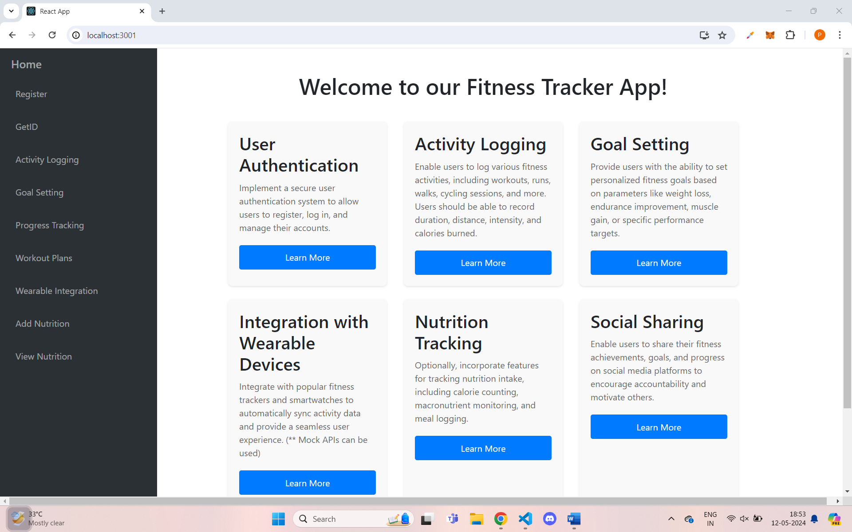

Register page

Register by giving the name and it will generate ID. Remember the ID for future purposes.

GetID page

If you forgot the ID, No problem. You can get the ID by giving your registered name.

Activity logging page

You can add Exercise Type, Note(Optinal), User ID and Sets(NumReps and Weight) and can add multiple sets and click on Log Activity. It will success fully logged into your UserID and you can track from Work out plans and also in Progress Tracking.

Goal Setting page

Here you can add Different types of Exercises for you.

Progress Tracking page

You can track your progress that is the total weight lifted

Workout Plans

Here you can track you workout plans by using UserID

Wearable Integration

You can connect to Wearable Devices

Add Nutrition Item page

You can add Nutrition Items (Calories, Protein, Carbohydrates, Fats) and UserID

View Nutrition page

You can view the Nutrition Items which are added by you using your UserID

